DSBA 6010: Milestone 3 Accompanying Documentation
Test Queries:
Easy
- Show me all products
- List all customers with their email addresses
- Show me products that are red in color
- How many customers do we have?
Medium
- What is the total sales amount?
- What is the average order quantity for internet sales?
- Show me all sales with product names
- List all orders with customer names and product names
- Show me sales from the year 2023
- What were the total sales in December 2023?
- What is the average unit price by product category?
Hard
- Show me sales by product category
- Show me total sales by country
- Show me the top 10 products by sales amount
- Who are the top 5 customers by total purchase amount?
- Which sales territory has the highest average order value?
Very Hard Queries
- Compare sales between 2023 and 2024 by quarter
- Show me the profit margin by product subcategory

Tools Provided to Models:
Establishing Database Connection:
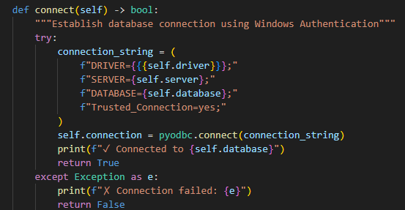
Retrieving Schema Information from Database
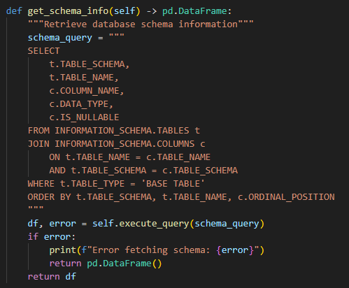
Get Table List from Database
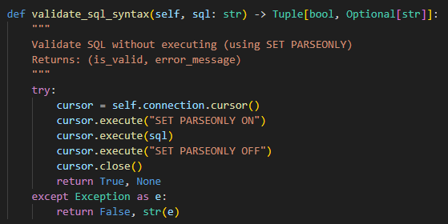

Generate Schema that can be fed to LLM
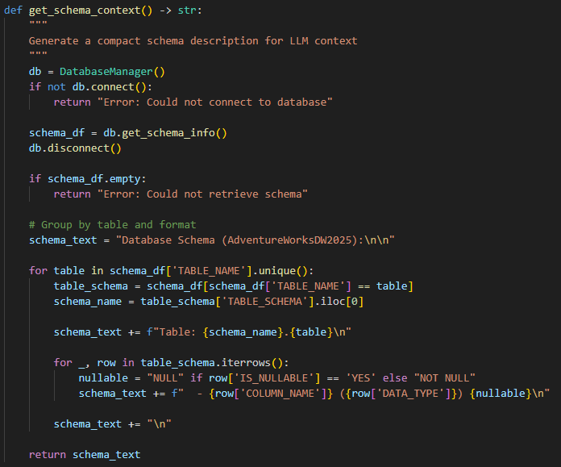

Prompt:
The following prompt was fed to all of the models. The {schema_context} and {natural_language_query} placeholders were replaced with actual values for each test case. These are defined in the functions above.
---
You are a SQL expert. Convert the following natural language query into a valid T-SQL for SQL Server.
Database Schema:
{schema_context}
Rules:
- Generate ONLY the SQL query, no explanations
- User proper table names with schema (e.g. dbo.TableName)
- User appropriate JOIN types
- Include TOP clause if asking for limited results
- Use proper date formatting for SQL Server
- The query should be executable as-is
Natural Language Query: {natural language query}
SQL Query:

